Population Dynamics

Exercise 1: Initial Explorations

1.1: A deer population – scenario 1
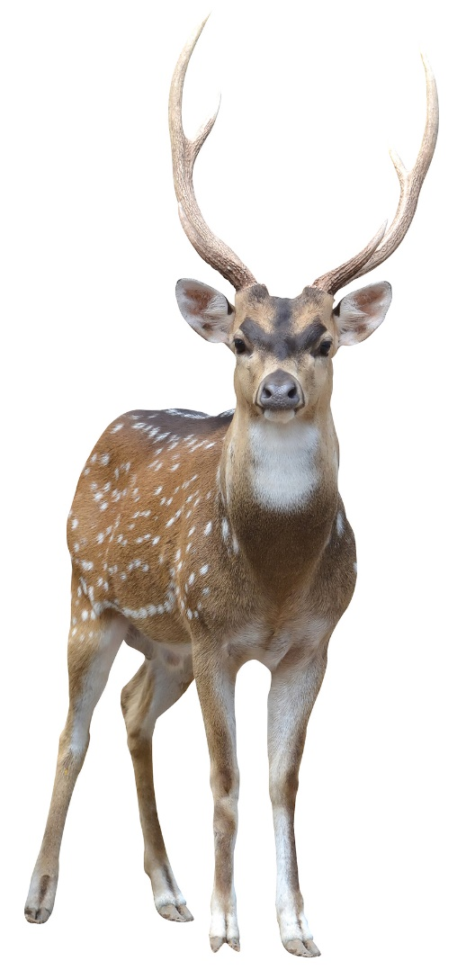
Imagine a population of deer living in a forest. Suppose the number of deer that die or emigrate (leave the forest) in a period of time exactly equals the number that are born or immigrate to the forest in that same time.
Write a sentence describing what might happen to the total number of deer over an extended period of time.
__________________________________________________________
__________________________________________________________
__________________________________________________________
The axes below show the population size (i.e. the number of deer) on the vertical axis and time on the horizontal axis. Complete the graph by adding a line showing the deer population as time passes.

1.2: A deer population – scenario 2
Let’s change the situation. Suppose that now there are more deer dying and leaving the forest than are being born or moving into the forest.
Write a sentence describing how the deer population will change over time now.
_____________________________________________________________________________________
_____________________________________________________________________________________

On the axes below sketch a new graph showing how you think the deer population will vary as time passes.

1.3: A deer population – scenario 3
Let’s change the situation one more time. Suppose that now there are more deer being born and immigrating to the forest than are dying or emigrating.
Write a sentence describing how the deer population will change over time now.
_____________________________________________________________________________________
_____________________________________________________________________________________
On the axes below sketch a new graph showing how you think the deer population will vary as time passes now.

1.4: Check your predictions
Go to http://profferings.ca/webapps/populations/. Select “Exponential Growth” from the menu near the top of the page. This page let’s you enter information about a population and then it will draw the resulting population graph. We will use it to see what happens to our deer population over time.
- Set any starting population size you want within the allowed range.
- Set “Growth rate” to 1.
- Click the “Apply changes” button to redraw the graph with your new values.
A growth rate of 1 means that the number of deer being born or immigrating into the forest exactly equals the number dying or emigrating from the forest in the same period of time.
How does the deer population over time compare with your prediction from scenario 1?
_____________________________________________________________________________________
_____________________________________________________________________________________
_____________________________________________________________________________________
_____________________________________________________________________________________
_____________________________________________________________________________________
_____________________________________________________________________________________
Now check your predictions from scenario 2. Keep your starting population the same but change “Growth rate” to 0.8 then click “Apply changes” to redraw the graph.
A growth rate less than 1 means that the number of deer being born or immigrating to the forest is less than the number of deer dying or leaving.
How does this graph compare with your predictions? Is the shape of the graph what you predicted?
_____________________________________________________________________________________
_____________________________________________________________________________________
_____________________________________________________________________________________
_____________________________________________________________________________________
_____________________________________________________________________________________
_____________________________________________________________________________________
What happens if we use other values less than 1 for “Growth rate”. Try a few different numbers (always less than 1) and see.

Now check your predictions from scenario 3. Keep your starting population the same but change “Growth rate” to 1.5 then click “Apply changes” to redraw the graph.
A growth rate greater than 1 means that _____________________________________________________________________
________________________________________________________________________________________________________________
________________________________________________________________________________________________________________

How does this graph compare with your predictions? Is the shape of the graph what you predicted?
_____________________________________________________________________________________
_____________________________________________________________________________________
_____________________________________________________________________________________
_____________________________________________________________________________________
_____________________________________________________________________________________
_____________________________________________________________________________________

Show this work to your teacher before continuing on.

Population Dynamics

Exercise 2: Exponential Growth

2.1: What is Exponential Growth?
In exercise 1, you finished up by graphing a growing deer population, i.e. a population where the number of deer being born or immigrating into the forest was greater than the number of deer dying or emigrating. In the mathematical model we are using, a growing population is represented by a growth rate value greater than 1.
All of the graphs below could represent a population whose numbers are increasing over time but only one correctly shows what really happens when a population is able to grow without limits. Which graph is correct?
population
time
population
time
population
time

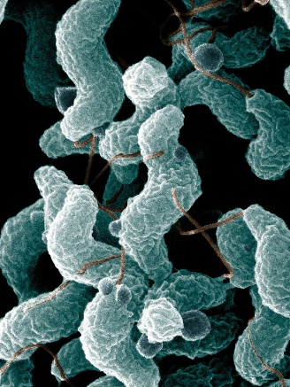
Consider a population of bacteria which can double in size every generation. Suppose we started with 1 bacterium.
After 1 generation we would have 2 bacteria.
After a 2nd generation we would have 4 bacteria.
After a 3rd generation we would have 8 bacteria.
After a 4th generation we would have ______ bacteria.
After a 5th generation we would have ______ bacteria.
Spiral Bacteria

Notice that the amount that the population is increasing by each generation is itself increasing. In the first growth period the bacteria population increased by 1. In the 2nd it increased by 2. In the 3rd growth period it increased by 4, and so on.
This type of growth is called exponential growth. A graph of exponential growth always has the same basic shape. It curves upwards. When populations are able to grow freely, i.e. when there is plenty of room and plenty of food to support a growing population, they will grow exponentially.

2.2: Graphing Exponential Growth
Go to http://profferings.ca/webapps/populations/. Select “Exponential Growth” from the menu near the top of the page. This is the same graphing tool that you used for exercise 1 of this series.
Let’s model the growth of our bacteria population from earlier in this exercise. This population doubled in size every generation. We can use a growth rate of 2 to represent this.
- Set the growth rate to 2.
- Set the starting population to 100. (The minimum number allowed.)
Sketch the shape of the resulting graph here.
What if the growth rate was different? A deer population, for example, probably wouldn’t double every generation. Perhaps an increase of 10% every generation might be more realistic. This would be represented by a growth rate number of 1.1. Try graphing this.
- Set the growth rate to 1.1.
- Set the starting population to 100, i.e. the same as for the bacteria.
What difference does the different growth rate make to the shape of the graph?
_____________________________________________________________________________________
_____________________________________________________________________________________
_____________________________________________________________________________________
_____________________________________________________________________________________
_____________________________________________________________________________________

Try graphing populations with several other growth rates. What happens to the general shape of the graph?
_____________________________________________________________________________________
_____________________________________________________________________________________

You should have noticed that the general shape of the graphs above didn’t change. They all showed the upward curve getting steeper over time. This is the typical exponential growth curve. Different growth rates result in curves that change more slowly or more rapidly as the case may be but they all have the same general shape. Notice that at first the population remains fairly small and increases relatively slowly but eventually it increases by much bigger steps each time period. After a period of time the population starts to skyrocket.

2.3: Things to Think About
Most diseases caused by organisms that invade your body have incubation periods. That means that you don’t usually show symptoms of the disease until some time after the disease-causing organisms have invaded your body. The common cold, for example has a typical incubation period of 1 to 3 days. If you get the measles, you won’t know it until 9 to 12 days after you contracted the virus. Can you explain these incubation periods in terms of exponential growth curves? Your explanation should include a labelled sketch graph.

Do you think a population will continue to grow exponentially at an ever increasing rate indefinitely? Why or why not? Give some specific reasons for your answer.
_____________________________________________________________________________________
_____________________________________________________________________________________
_____________________________________________________________________________________
_____________________________________________________________________________________
_____________________________________________________________________________________
_____________________________________________________________________________________
_____________________________________________________________________________________
_____________________________________________________________________________________
_____________________________________________________________________________________
_____________________________________________________________________________________

Show this work to your teacher before continuing on.

Population Dynamics

Exercise 3: Logistic Growth

3.1: Limiting Factors
In exercise 2 you saw that, when conditions are favourable, populations increase exponentially. Population increase is small at first but the size of the population increases by an ever increasing amount as time goes on.
This type of growth cannot be sustained indefinitely. Eventually populations will encounter limiting factors.
Consider a small population of fish in a lake. At first there are few fish and the lake is large. The population will grow exponentially. As the population becomes very large, though, the fish will run into problems.
Suggest three things that might prevent the population of fish in the lake from increasing further. Write full sentences.
- ______________________________________________________________________________

______________________________________________________________________________

______________________________________________________________________________

- ______________________________________________________________________________

______________________________________________________________________________

______________________________________________________________________________

- ______________________________________________________________________________

______________________________________________________________________________

______________________________________________________________________________

One obvious limitation to population growth is the amount of available space. The lake has a fixed size. There is a maximum number of fish that can fit in it. Similarly, the number of deer that can live in a forest is limited by the size of the forest. As the population approaches the maximum the space allows other factors come into play. Food supplies become limited and must be shared among more individuals. As populations become more crowded disease can spread more easily. These things and more result in a larger percentage of the population dying or emigrating than would happen when space and resources are plentiful.
Factors that limit population growth can be divided into two types – (1) density dependent factors and (2) density independent factors. Do some internet research to complete the rest of this section.
- Define these terms:
  - Limiting factor

  - Density dependent

  - Density independent

- Give three examples of each type of limiting factor. Be prepared to explain
Density dependent limiting factors

- ________________________________________________________________________

- ________________________________________________________________________

- ________________________________________________________________________

Density independent limiting factors

- ________________________________________________________________________

- ________________________________________________________________________

- ________________________________________________________________________

3.2: Logistic Growth
Let’s look at graphs showing how populations change when limiting factors come into play. Go to http://profferings.ca/webapps/populations/. Select “Logistic Growth” from the menu near the top of the page.
These graphs are calculated using a mathematical model that assumes that the death/emigration rate increases as the population increases. In other words, as the population gets larger a bigger percentage of the population will die or emigrate away from the environment each time period.
Notice that this graph has the same options as the exponential growth graph. “Growth rate” has been relabelled as “Ideal growth rate.” It means the same as it did on the earlier graphs. It represents the rate at which the population increases when there are no limiting factors. Now, however, this rate is further modified as the population increases. Think of this number as “birth rate minus death rate”. The bigger the population gets the bigger the death rate gets.
Try varying the starting population and the ideal growth rate, but keep the growth rate between 1 and 2 (we’ll explore larger values later). Describe in words what happens to the population over time.
________________________________________________________________________________________________________________
________________________________________________________________________________________________________________
________________________________________________________________________________________________________________
Sketch the general shape of the graphs you are seeing.
This growth pattern, where limiting factors prevent the population from continuing to increase, is known as logistic growth. The resulting population graph is called a logistic curve, also known as an “S” curve because it looks a bit like a distorted letter S. (The exponential growth curve that you explored in earlier lessons is sometimes called a “J” curve since it slightly resembles the shape of that letter.)

The maximum population size that an environment can support is called the carrying capacity of that species in that environment.
Suppose there is a species of mouse living in a forest and that the ideal growth rate of the mouse population is 1.2 . Using the online graph to model this situation. Set a value of 1.2 for the ideal growth rate.
- What is the carrying capacity of this mouse species in this forest according to the graph (give the number)?
______________
- What difference does changing the starting population of mice make to the carrying capacity? Why do you think that is?

______________________________________________________________________________
______________________________________________________________________________
______________________________________________________________________________
______________________________________________________________________________

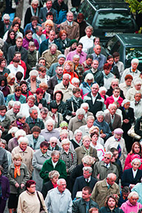
3.3: Things to Think About
Consider the human population of the earth. Do some web research to answer the following questions.
- What is the approximate number of humans on earth now?

__________________________________________________
- About how many people were on the planet 100 years ago (i.e. around the year 1900).

__________________________________________________
- About how many people were on the planet 200 years ago (i.e. around the year 1800).

__________________________________________________

- Based on your internet research, sketch a graph of human population growth up to the present time.

- Based on the material in this lesson sketch what a graph of human population might look like into the significant future.

- Do some web research. What do the experts say that the carrying capacity of humans on the earth is?

______________________________________________________________________________

- Cite the source of your prediction using a standard citation format (e.g. MLA or similar).

______________________________________________________________________________

______________________________________________________________________________

- What kinds of problems are likely to occur as the human population approaches the carrying capacity?

______________________________________________________________________________

______________________________________________________________________________

______________________________________________________________________________

______________________________________________________________________________

______________________________________________________________________________

______________________________________________________________________________

______________________________________________________________________________

______________________________________________________________________________

- What can we do about it?

______________________________________________________________________________

______________________________________________________________________________

______________________________________________________________________________

______________________________________________________________________________

______________________________________________________________________________

______________________________________________________________________________

______________________________________________________________________________

______________________________________________________________________________

Show this work to your teacher before continuing on.

Population Dynamics

Exercise 4: More about Logistic Growth

4.1: Population Growth Reviewed
In earlier exercises you saw how populations increase when they have more than enough resources available to them.
Sketch a graph that shows this form of growth.

This type of growth is called ________________________ growth. The graph is known as an
exponential growth curve, also called a _____ curve.
You also saw what happens to populations when the population size approaches the limits of the environment’s ability to support it.
Sketch a graph of showing population growth with limiting factors.

This type of growth is called ___________________________ growth. The graph is known as a logistic
growth curve, also called an _____ curve.
The maximum number of individuals of a species that an environment can support is called the
_____________________________________________ .

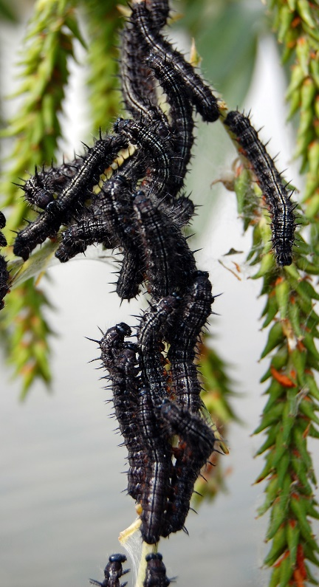
4.2: Logistic Growth and Rapid Growth Rates
In exercise 3, you looked at examples where the ideal growth rate was kept to a value of 2 or less. In other words, you focused on populations which grew at relatively low rates. These populations increased until they eventually levelled off at the carrying capacity. Once the carrying capacity was reached the population size did not change.
What about populations that can increase rapidly? Go to http://profferings.ca/webapps/populations/. Select “Logistic Growth” from the menu near the top of the page.
Enter a value of 2.7 for the ideal growth rate. Sketch the graph below in a way that clearly highlights the difference between this graph and the graphs resulting from growth rates less than two.

Describe in words what happens when this population nears its carrying capacity. Your description should clearly indicate how this population differs from populations with lower growth rates.
________________________________________________________________________________________________________________
________________________________________________________________________________________________________________
________________________________________________________________________________________________________________
________________________________________________________________________________________________________________
________________________________________________________________________________________________________________
________________________________________________________________________________________________________________
You should have noticed that the population actually exceeded the carrying capacity briefly, then dropped below the carrying capacity and continued to oscillate above and below the carrying capacity for a short time before settling into a constant value.
Complete these sentences:
When the population is greater than the carrying capacity the birth/immigration rate becomes
_____________________ the death/emigration rate and the population ________________ in size.
When the population is less than the carrying capacity the birth/immigration rate becomes
_____________________ the death/emigration rate and the population ________________ in size.

If you increase the ideal growth rate to 2.9 do you see the same pattern? (Remember, you can use the buttons to adjust the time period.)
_____________
What does the population size settle down to in this case? _______________
Let’s explore even higher growth rates. Try a value of 3.2 for the ideal growth rate. Does the population settle to a constant value?
______________
Write a sentence explaining what happens to the population under these circumstances.
________________________________________________________________________________________________________________
________________________________________________________________________________________________________________
________________________________________________________________________________________________________________
________________________________________________________________________________________________________________
________________________________________________________________________________________________________________

What do you think the carrying capacity is for this population? Explain how you could figure it out from the graph.
________________________________________________________________________________________________________________
________________________________________________________________________________________________________________
________________________________________________________________________________________________________________
________________________________________________________________________________________________________________
________________________________________________________________________________________________________________
Try several different values between 3 and 3.5 for the ideal growth rate. Notice that you always get a repeating pattern, although the pattern gets more complex as the growth rate increases. Mouse over the graph to read values from it. Convince yourself that these are repeating patterns.

4.3: Very Rapid Growth Rates and Chaos
In exercise 3 and earlier parts of this exercise you have seen how populations behave when they approach the limit that their environment can support.
- Populations with relatively low growth rates reach their maximum number and stay there.
- Populations with higher growth rates settle into a repeating pattern where the population size varies above and below the carrying capacity in a regular manner.
What about for even higher growth rates?
Set the ideal growth rate to 3.7 and examine the resulting population graph. Does it settle into a steady value? Does it settle into a repeating pattern? Try other rates between 3.7 and the maximum value of 4 that this simulation allows. What happens?
________________________________________________________________________________________________________________
________________________________________________________________________________________________________________
________________________________________________________________________________________________________________
________________________________________________________________________________________________________________
You should observe that there is no repeating pattern. It doesn’t matter how far into the future you calculate, there is never a repeating pattern. You might think you see one but check the values and you will see that it never repeats exactly. You may think it might repeat eventually but it won’t. This is what scientists call a chaotic state. In this situation there is no way for scientists to predict what a population size might be at any time in the future other than to calculate it out.
Chaotic states have another notable characteristic. Very small changes in initial conditions can result in large differences in output. Here’s an example to illustrate this:
Suppose you are responsible for predicting the size of the deer population in a forest for years into the future. We just said that there is no way to predict the future population other than by calculating it out. So, you go into the forest and count the deer then use this computer model to calculate future populations. Suppose you count 400 deer and that their reproduction rate is 3.8. plug these values into the computer model. Assuming each time period is a year, what will the deer population be in 15 years time?
______________
Oops, you missed a couple. Suppose the actual deer population was 402. Recalculate with this initial value. What does the computer say the population will be in 15 years time now?
______________
Perhaps you can begin to see that predicting future population sizes can be a difficult and sometimes impossible thing to do.

4.4: Keeping it Real
In the previous section we saw how a small miscount in the deer population made it impossible to accurately predict the population very far into the future. In reality this is unlikely to happen with deer. Can you explain why? (Hint: what does a growth rate of 3.8 mean?)
________________________________________________________________________________________________________________
________________________________________________________________________________________________________________
________________________________________________________________________________________________________________
________________________________________________________________________________________________________________
What types of organisms might this happen with?
________________________________________________________________________________________________________________
________________________________________________________________________________________________________________
________________________________________________________________________________________________________________
________________________________________________________________________________________________________________

The models we have been using in all the exercises up to this point have been very simple ones. Few real populations will behave in exactly this way. That’s because organisms interact with other organisms. They eat or are eaten by others. They compete with other species for resources. Some species cooperate with each other. These interactions affect how population grow. In the next exercise we will look at a population model that examines interactions between two species.

Show this work to your teacher before continuing on.

Population Dynamics

Exercise 5: Predator-Prey Relationships

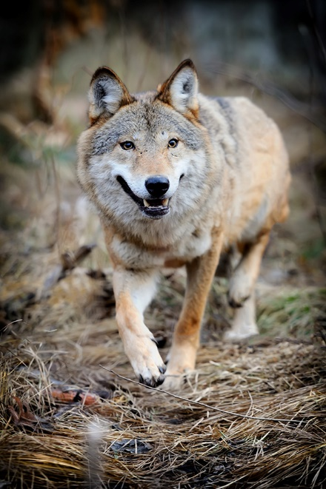
5.1: Graphing predator-prey relationships
Up to now we have focused on populations in isolation. In reality populations interact in many complex ways with populations of other species. In this exercise we will focus on one type of interspecies interaction, the predator-prey relationship.
A predator-prey interaction focuses on two species, one of which feeds on the other. For example, we could talk about populations of foxes and rabbits, or sharks and tuna, or ladybugs and aphids, or owls and mice, and so on.
Consider a large population of deer in a forest. Suppose a small population of wolves is then introduced into the forest. Wolves feed on deer.
What do you think will happen to the wolf population when the deer population is large? Why?
_____________________________________________________________________________________
_____________________________________________________________________________________
_____________________________________________________________________________________
What do you think will happen to the wolf population when the deer population is small? Why?
_____________________________________________________________________________________
_____________________________________________________________________________________
_____________________________________________________________________________________
What do you think will happen to the deer population when the wolf population is large? Why?
_____________________________________________________________________________________
_____________________________________________________________________________________
_____________________________________________________________________________________
What do you think will happen to the deer population when the wolf population is small? Why?
_____________________________________________________________________________________
_____________________________________________________________________________________
_____________________________________________________________________________________
Ecologists have studied many such relationships and have produced mathematical models that show how populations of predators and prey change over time. In this exercise we will explore one simple model. Go to http://profferings.ca/webapps/populations/. Select “Predator-Prey” from the menu near the top of the page then “Basic” from the sub-menu.
This model graphs two populations at the same time, the predator and the prey. You have similar options as in earlier graphs for each population: starting population size and ideal growth rate. In addition, you have two other factors. “Prey nutritional value” is a number that represents the efficiency of the predators in turning food into more predators. Bigger values mean that the predator population grows at a faster rate with the same amount of food. “Predator effectiveness” is an indicator of the hunting ability of the predators or, if you prefer, the ability of the prey to avoid the predators. You don’t need to understand these numbers or the math. Our concern here is to see what these models tell us about how populations behave.
Try changing some of these values to see what happens to the populations. You can manually change variables or you can use the “Random values” button for new combinations.
After trying many different sets of values make a general statement about the shape of predator-prey graphs.
_____________________________________________________________________________________
_____________________________________________________________________________________
_____________________________________________________________________________________
Sketch a population-time graph in the space below that shows a “typical” predator-prey pattern. Use different colours for the predator and prey data.

When does the predator population reaches its maximum size? Make a general statement which is true regardless of the actual values used.
_____________________________________________________________________________________
_____________________________________________________________________________________
_____________________________________________________________________________________

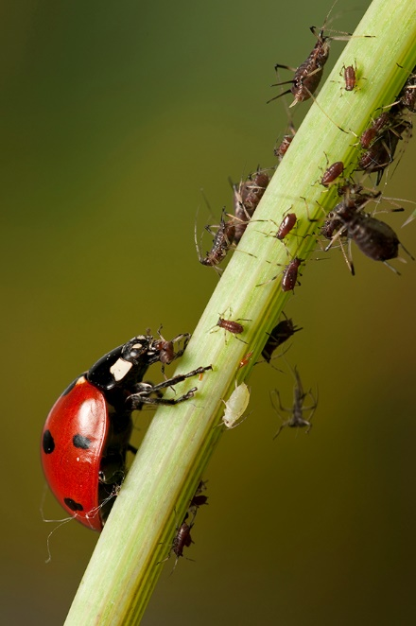
5.2: Making predictions
This section is meant to get you thinking about your next exercise, which, unlike the exercises so far, will count for marks.
Suppose you are a farmer growing sugar beet. You have a problem with aphids damaging your sugar beet plants. Aphids are tiny insects that eat the leaves and also spread harmful viruses as they do so. If left uncontrolled, their population can increase rapidly. One way to control aphids is to introduce a predator. Ladybugs, particularly their larvae, are voracious predators of aphids. Farmers can purchase ladybugs from suppliers to introduce into their fields to control pests.
What would you expect to happen if you introduced ladybugs into your sugar beet fields?
_____________________________________________________________________________________
_____________________________________________________________________________________
_____________________________________________________________________________________
What if you increased the number of lady bugs that you introduced?
_____________________________________________________________________________________
_____________________________________________________________________________________
_____________________________________________________________________________________
Try experimenting with the model. Aphids are the prey. Use a large starting number for them. Ladybugs are the predators. Try adjusting predator numbers in a logical manner and see what happens.
Do you notice anything?
_____________________________________________________________________________________
_____________________________________________________________________________________
_____________________________________________________________________________________
Show this work to your teacher before continuing on.

Population Dynamics

Project 1: Biological Pest Control

This assignment counts for marks. You can work individually or in pairs. You will hand in a typed, professional looking report when the assignment is complete.
You are a consultant with the agricultural department. Local market gardeners are having problems with spider mites damaging their vegetable crops. Spider mites are tiny organisms relate to spiders. They reproduce rapidly and feed off the leaves of plants, doing damage to the plants in the process and spreading harmful viruses around the plants as they feed. The damage they do can seriously affect the productivity of the industry. One method of controlling the spider mites is to introduce a different species of predatory mite that feeds on spider mites. These are commercially available to farmers for just this purpose.
A market gardener has come to you for advice on using predatory mites to control his spider mite problem. He assumes that the more predatory mites he introduces, the faster he will be able to control his problem. Your job is to determine the optimum number of predatory mites for his situation.
Ecologists in your agricultural department have studied populations of spider mites and predatory mites and produced a mathematical model to predict changes in their populations over time as they interact. This model is can be found at http://profferings.ca/webapps/populations/. Select “Predator-Prey” from the menu near the top of the page then “Basic” from the sub-menu. You will use this model to predict the optimum number of predatory mites for the farmer to use and prepare a report of your findings for the farmer.
For this exercise assume the following starting values:
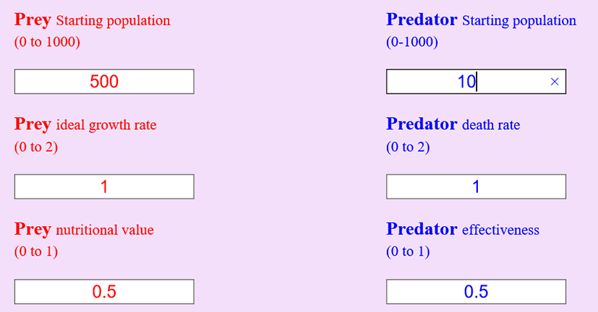
The population sizes are the number of mites per square metre of market garden.

The best approach to this problem is probably to use the model to see what effect different numbers of predators will have on the prey population size. Start by seeing what would happen to the prey population when no predators are present. Now, introduce a small number of predators per square metre to see what effect they have. Trying increasing the number of predators, observing the effect each time.
Things to think about.
- Are more predators better or is there an optimum number?
- Is it possible to completely eradicate the pests this way?
You will prepare a report for your client with your recommendation. Your report should…
- Clearly state the problem that was investigated.
- Briefly explain how you conducted the investigation.
- Show all data from your investigation on a suitable table.
- Clearly outline your recommendations to your client, explaining the rationale behind them.
Hand in a typed, professional looking report such as you might provide to your client.

----------------------------------------------------------------

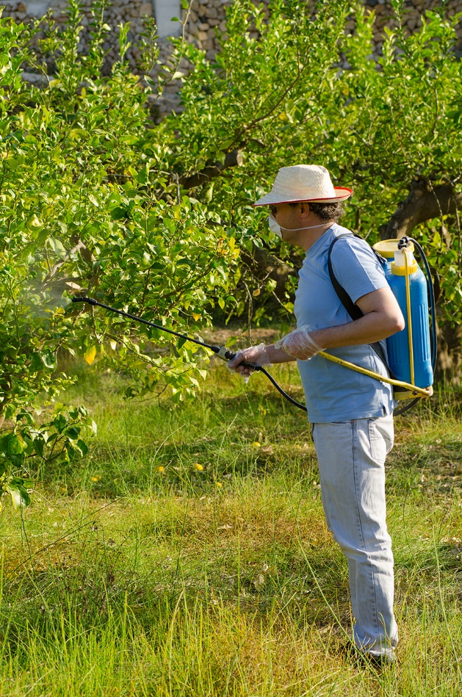
Population Dynamics

Project 2: Pest Control – Part 2

This assignment counts for marks. You will work individually. You will hand in a typed, professional looking report when the assignment is complete.
You are a consultant with the agricultural department. In a previous assignment you helped a local market gardener who was having problems with spider mites damaging his vegetable crops. The farmer wanted to address the spider mite problem by introducing a different species of predatory mite that feeds on spider mites. You advised the farmer on the optimum number of predatory mites to introduce per square metre in order to maximize their effect. You determined this number by experimenting with a simple predator-prey population model.
The market gardener has returned to ask you for more advice. The predatory mites are helping to control the damaging spider mites as expected but the farmer is impatient and wants to do more. He is considering spraying his crops with a pesticide in order to further reduce the number of spider mites attacking his vegetables. Your job is to research the situation and advise the farmer on the best course of action.
To research the effects of pesticides you will use another mathematical population model that ecologists in your agricultural department have developed. This is called a “Predator-Prey with fishing” model. You will find this model at http://profferings.ca/webapps/populations/. Select “Predator-Prey” from the menu near the top of the page then “…with fishing” from the sub-menu.
This model is very similar to the basic predator-prey model that you used in your previous assignment except that it introduces a “fishing” term. The word "fishing" refers to any situation where both the predator and prey populations are hunted or harvested equally. For example, it might refer to fisherman harvesting both sharks and tuna. It might describe the effects of hunting on wolf and deer populations where both species are hunted equally. In this case “fishing” refers to the spraying of pesticides that will kill both predator mites and prey mites equally.
You will use this model to predict the effect of spraying different amounts of pesticides on the populations and to advise the market gardener based on your findings.

For this exercise use the following starting values:
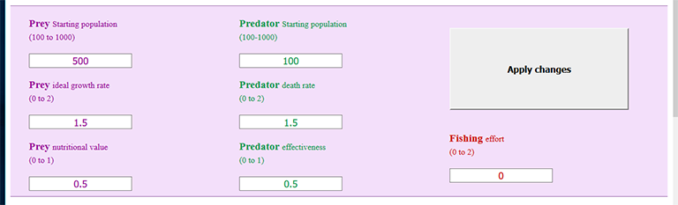
The only value you will change is the number representing “Fishing effort”. The exact number doesn’t matter. Just think of bigger values as using more pesticide. A fishing effort of zero means no pesticide is being used and fishing effort of “2” represents a very large amount of pesticide.
The best approach to this problem is probably to start with a fishing value of “0”. This shows the variation in predator and prey populations when no insecticide is used. Now gradually increase the amount of insecticide sprayed on the crops by increasing the “Fishing effort” value, noting what effect this has on predator and prey populations each time.
Things to think about.
- Predict what you think will happen before you experiment with the model.
- Recall that pesticides will kill both predator and prey mites equally (and what else?).
- You are specifically investigating the effects of the pesticide on the predator and prey mites but what other effects might the spraying have?
You will prepare a report for your client with your recommendation. Your report should…
- Clearly state the problem that was investigated.
- Briefly explain how you conducted the investigation.
- Show all data from your investigation on a suitable table.
- Clearly outline your recommendations to your client, explaining the rationale behind them.
Hand in a typed, professional looking report such as you might provide to your client.

----------------------------------------------------------------

